NVQ LEVEL 5
Database Systems Unit
Practical Evidence Report
Farook Mussarf
Index No :
Project: Library Automation System
Relational database design, normalization,
ER diagram and SQL practical work
Table of Contents
1. Introduction 2
2. Relational Database — Basic Concepts 2
3. Entity-Relationship (ER) Diagram 3
4. Database Design — Tables 4
1. Members 4
2. Staff 5
3. Categories 6
4. Authors 6
5. Books 6
6. Book_Authors 7
7. Book_Copies 7
8. Loans 8
9. Fines 8
10. Notifications 9
5. Normalization 10
5.1 First Normal Form (1NF) 10
5.2 Second Normal Form (2NF) 10
5.3 Third Normal Form (3NF) 10
6. Practical Work — SQL Implementation 11
6.1 Schema (DDL) — excerpt 11
6.2 Sample Data 12
6.3 Queries Extracting Records From Two or More Tables 12
Q1 — Overdue loans with member name, book title and due date (4-table JOIN) 12
Q2 — Total unpaid fine amount per member (JOIN + GROUP BY + SUM) 12
Q3 — Every book with its category and author (4-table JOIN) 13
Q4 — Books with zero available copies (JOIN + GROUP BY + HAVING) 13
Q5 — Members currently blocked from borrowing (single-table filter) 13
7. Conclusion 15

1. Introduction
This report presents the Database Systems evidence for the Library Automation System project. The system is a Java-backed application (with a companion web interface) that manages book lending, member registration, overdue fines and automated email notifications for a library. This document covers the relational database basic concepts, the key concepts of relationships, the Entity-Relationship (ER) diagram, the normalization process applied to the design, and the practical SQL implementation including queries that extract data from two or more tables.

2. Relational Database — Basic Concepts
A relational database organizes data into tables (relations), each made up of rows (tuples/records) and columns (attributes/fields). The core building blocks used throughout this design are:
- Table (Relation): a structured set of data organized in rows and columns, e.g. Members, Books.
- Tuple (Row/Record): a single entry in a table, e.g. one specific member.
- Attribute (Column/Field): a named property of the entity, e.g. email, due_date.
- Primary Key (PK): a column (or set of columns) that uniquely identifies each row in a table, e.g. member_id.
- Candidate Key: a column that could serve as a primary key, e.g. email in Members is a candidate key (declared UNIQUE).
- Foreign Key (FK): a column that references the primary key of another table, enforcing referential integrity, e.g. Books.category_id references Categories.category_id.
- Composite Key: a primary key made of more than one column, e.g. the (book_id, author_id) pair in Book_Authors.
- Referential Integrity: FK constraints ensure a loan can never reference a member or book copy that doesn't exist.

Relationships
Three types of relationship occur in this design:
- One-to-Many (1:N): one Member can have many Loans, but each Loan belongs to exactly one Member. The same pattern applies to Categories → Books, Books → Book_Copies, Staff → Loans, Loans → Fines and Members → Notifications.
- Many-to-Many (M:N): a Book can have several Authors, and an Author can write several Books. This is resolved using the Book_Authors junction table, which converts the M:N relationship into two 1:N relationships.
- Optional relationship (0:N): a Notification may or may not be tied to a specific Loan (e.g. a general account notice), so Notifications.loan_id is a nullable foreign key.

3. Entity-Relationship (ER) Diagram
The diagram below uses crow's-foot notation. An arrow with a crow's foot indicates the many side of a relationship, the plain end indicates the one side. Dashed lines indicate an optional relationship.

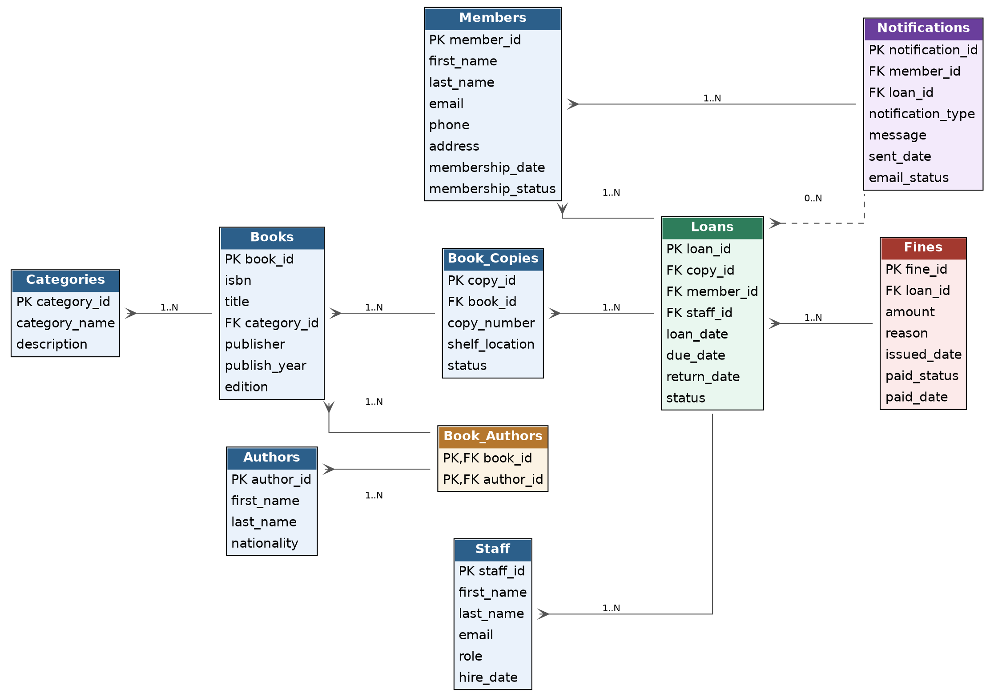
Figure 1: Entity-Relationship diagram for the Library Automation System database.

4. Database Design — Tables
The schema consists of 10 tables, summarized below, followed by a detailed field-level breakdown of each.
Table | Purpose
Members | Stores every registered library member and their membership status.
Staff | Stores librarians/administrators who process loans and returns.
Categories | Classifies books into subject categories (genres).
Authors | Stores author details, independent of any one book.
Books | One row per distinct title held by the library (not per physical copy).
Book_Authors | Junction table resolving the Many-to-Many relationship between Books and Authors (a book may have several authors; an author may write several books).
Book_Copies | Tracks each individual physical copy of a title, since the library may own several copies of the same book.
Loans | Records every lending transaction linking a member, a specific copy and the staff member who processed it.
Fines | Records fines (overdue, damage, lost) issued against a specific loan.
Notifications | Logs every automated email sent to a member (due reminders, overdue alerts, return confirmations, fine notices).

1. Members
Stores every registered library member and their membership status.
Field | Type | Key | Description
member_id | INT (AI) | PK | Unique identifier for the member
first_name | VARCHAR(50) |  | Member's first name
last_name | VARCHAR(50) |  | Member's last name
email | VARCHAR(100) | UNIQUE | Used for login and automated notifications
phone | VARCHAR(15) |  | Contact number
address | VARCHAR(150) |  | Postal address
membership_date | DATE |  | Date the member joined
membership_status | ENUM |  | Active / Suspended / Expired

2. Staff
Stores librarians/administrators who process loans and returns.
Field | Type | Key | Description
staff_id | INT (AI) | PK | Unique identifier for the staff member
first_name | VARCHAR(50) |  | Staff first name
last_name | VARCHAR(50) |  | Staff last name
email | VARCHAR(100) | UNIQUE | Staff login email
role | ENUM |  | Librarian / Assistant / Admin
hire_date | DATE |  | Date the staff member was hired

3. Categories
Classifies books into subject categories (genres).
Field | Type | Key | Description
category_id | INT (AI) | PK | Unique identifier for the category
category_name | VARCHAR(60) | UNIQUE | e.g. Computer Science, Fiction
description | VARCHAR(200) |  | Short description of the category

4. Authors
Stores author details, independent of any one book.
Field | Type | Key | Description
author_id | INT (AI) | PK | Unique identifier for the author
first_name | VARCHAR(50) |  | Author's first name
last_name | VARCHAR(50) |  | Author's last name
nationality | VARCHAR(50) |  | Author's nationality

5. Books
One row per distinct title held by the library (not per physical copy).
Field | Type | Key | Description
book_id | INT (AI) | PK | Unique identifier for the title
isbn | VARCHAR(20) | UNIQUE | International Standard Book Number
title | VARCHAR(150) |  | Book title
category_id | INT | FK | References Categories.category_id
publisher | VARCHAR(100) |  | Publishing house
publish_year | YEAR |  | Year of publication
edition | VARCHAR(20) |  | Edition label (1st, 2nd, Reprint...)

6. Book_Authors
Junction table resolving the Many-to-Many relationship between Books and Authors (a book may have several authors; an author may write several books).
Field | Type | Key | Description
book_id | INT | PK, FK | References Books.book_id
author_id | INT | PK, FK | References Authors.author_id

7. Book_Copies
Tracks each individual physical copy of a title, since the library may own several copies of the same book.
Field | Type | Key | Description
copy_id | INT (AI) | PK | Unique identifier for the physical copy
book_id | INT | FK | References Books.book_id
copy_number | INT |  | Sequential copy number for that title
shelf_location | VARCHAR(20) |  | Physical shelf code
status | ENUM |  | Available / Loaned / Lost / Damaged

8. Loans
Records every lending transaction linking a member, a specific copy and the staff member who processed it.
Field | Type | Key | Description
loan_id | INT (Auto Increment) | PK |  | Unique identifier for the loan transaction
copy_id | INT | FK |  | References Book_Copies.copy_id
member_id | INT | FK |  | References Members.member_id
staff_id | INT | FK |  | References Staff.staff_id
loan_date | DATE |  |  | Date the book was borrowed
due_date | DATE |  |  | Date the book is due back
return_date | DATE (null) |  |  | Date actually returned
status | ENUM |  |  | Active / Returned / Overdue

9. Fines
Records fines (overdue, damage, lost) issued against a specific loan.
Field | Type | Key | Description
fine_id | INT (AI) | PK | Unique identifier for the fine
loan_id | INT | FK | References Loans.loan_id
amount | DECIMAL(8,2) |  | Fine amount in LKR
reason | ENUM |  | Overdue / Damage / Lost
issued_date | DATE |  | Date the fine was issued
paid_status | ENUM |  | Unpaid / Paid
paid_date | DATE (null) |  | Date the fine was settled

10. Notifications
Logs every automated email sent to a member (due reminders, overdue alerts, return confirmations, fine notices).
Field | Type | Key | Description
notification_id | INT (AI) | PK | Unique identifier for the notification
member_id | INT | FK | References Members.member_id
loan_id | INT (null) | FK | References Loans.loan_id (nullable)
notification_type | ENUM |  | Due Reminder / Overdue Alert / Return Confirmation / Fine Notice
message | VARCHAR(255) |  | Rendered email body/summary
sent_date | DATETIME |  | Timestamp the email was sent
email_status | ENUM |  | Sent / Failed / Pending

5. Normalization
Normalization is the process of structuring a relational database to reduce data redundancy and avoid update, insertion and deletion anomalies. Each normal form is demonstrated below using this design.

5.1 First Normal Form (1NF)
A table is in 1NF if every column holds a single (atomic) value and there are no repeating groups.
- Applied: A naive design might store multiple authors in one column of Books (e.g. 'author1, author2'). This design instead gives every book a single title row and moves the potentially multi-valued author information into a separate Book_Authors table satisfying atomicity.

5.2 Second Normal Form (2NF)
A table is in 2NF if it is in 1NF and every non-key attribute is fully functionally dependent on the whole primary key (relevant mainly to tables with composite keys).
- Applied: Book_Authors has the composite key (book_id, author_id) and holds no other attributes, so there is no partial dependency. Placing book title or author nationality in this table would have violated 2NF, since those attributes depend only on part of the composite key they are correctly kept in Books and Authors instead.

5.3 Third Normal Form (3NF)
A table is in 3NF if it is in 2NF and has no transitive dependencies (non-key attributes must not depend on other non-key attributes).
- Applied: category_name and description depend only on category_id, not on any other Books attribute, so Categories was separated into its own table rather than repeating the category name/description on every book row.
- Applied: Fines are kept in their own table rather than as extra columns on Loans, because fine amount/reason/paid_status depends on the fine itself, not directly on the loan's other attributes (a loan may have zero or more fines over time).
- Applied: Notifications reference Members and Loans by ID rather than duplicating member email or book title inside every notification row, avoiding transitive dependency on data that already lives elsewhere.
Overall, the schema is normalized to 3NF: every table has a clear single-subject purpose, all non-key attributes depend overall primary key and nothing but the key and repeating/multi-valued data (authorship) has been resolved through a junction table.

6. Practical Work — SQL Implementation
The full schema was implemented in MySQL 8.0 and validated by executing it (with an equivalent SQLite build used for local logic-testing) together with sample data of 5+ rows per table.

6.1 Schema (DDL) — excerpt
Full script: sql/01_schema.sql. Example — the Loans table, which references three other tables:
CREATE TABLE Loans (
loan_id INT AUTO_INCREMENT PRIMARY KEY,
copy_id INT NOT NULL,
member_id INT NOT NULL,
staff_id INT NOT NULL,
loan_date DATE NOT NULL,
due_date DATE NOT NULL,
return_date DATE NULL,
status ENUM('Active','Returned','Overdue') NOT NULL DEFAULT 'Active',
FOREIGN KEY (copy_id) REFERENCES Book_Copies(copy_id),
FOREIGN KEY (member_id) REFERENCES Members(member_id),
FOREIGN KEY (staff_id) REFERENCES Staff(staff_id)
);

6.2 Sample Data
Full script: sql/02_sample_data.sql — inserts 5 to 9 rows into each of the 10 tables, including overdue loans, paid/unpaid fines and a sent/pending notification log so that every query below returns meaningful results.

6.3 Queries Extracting Records From Two or More Tables
Full script: sql/03_practical_queries.sql. Each query below was executed against the sample data; the returned rows are shown beneath each query.

Q1 — Overdue loans with member name, book title and due date (4-table JOIN)
SELECT l.loan_id, CONCAT(m.first_name,' ',m.last_name) AS member_name,
b.title, l.due_date
FROM Loans l
JOIN Members m ON l.member_id = m.member_id
JOIN Book_Copies bc ON l.copy_id = bc.copy_id
JOIN Books b ON bc.book_id = b.book_id
WHERE l.status = 'Overdue';

Result:
- loan_id=1, Nadeesha Perera, Clean Code, due 2024-11-15
- loan_id=4, Ruwan Jayasuriya, Headfirst Java, due 2024-11-03

Q2 — Total unpaid fine amount per member (JOIN + GROUP BY + SUM)
SELECT CONCAT(m.first_name,' ',m.last_name) AS member_name, SUM(f.amount) AS total_unpaid
FROM Fines f
JOIN Loans l ON f.loan_id = l.loan_id
JOIN Members m ON l.member_id = m.member_id
WHERE f.paid_status = 'Unpaid'
GROUP BY m.member_id;

Result:
- Nadeesha Perera, total_unpaid = 150.00

Q3 — Every book with its category and author (4-table JOIN)
SELECT b.title, c.category_name, CONCAT(a.first_name,' ',a.last_name) AS author_name
FROM Books b
JOIN Categories c ON b.category_id = c.category_id
JOIN Book_Authors ba ON b.book_id = ba.book_id
JOIN Authors a ON ba.author_id = a.author_id
ORDER BY c.category_name, b.title;

Result:
- 6 rows returned — e.g. Clean Code | Computer Science | Robert Martin
- 1984 | Fiction | George Orwell
- Sapiens... | Science | Yuval Noah Harari

Q4 — Books with zero available copies (JOIN + GROUP BY + HAVING)
SELECT b.title, COUNT(bc.copy_id) AS total_copies
FROM Books b
JOIN Book_Copies bc ON b.book_id = bc.book_id
GROUP BY b.book_id
HAVING SUM(CASE WHEN bc.status='Available' THEN 1 ELSE 0 END) = 0;

Result:
- Sapiens: A Brief History of Humankind (1 copy, on loan)
- Headfirst Java (2 copies — 1 loaned, 1 lost)

Q5 — Members currently blocked from borrowing (single-table filter)
SELECT first_name, last_name, membership_status FROM Members
WHERE membership_status IN ('Suspended','Expired');

Result:
- Ruwan Jayasuriya — Suspended
- Sanduni Gunawardena — Expired

7. Conclusion
The Library Automation System database satisfies the Database Systems unit requirements: it contains 10 tables (more than the required 7) populated with realistic sample data, models One-to-Many, Many-to-Many and optional relationships correctly, is normalized to 3NF, and demonstrates practical SQL queries that extract and aggregate data across multiple tables. This schema forms the persistence layer for the Software Programming, Web Programming and SAD units that follow.

